Draft Minutes
Cold Ashby Parish Council
Minutes of the meeting held on on Wednesday June 5th 2024 at 7.30 pm at Cold Ashby Pavilion
Present: Councillors Roper (Chair, SR), Bailey (RB), Harpham (Vice-Chair, NH) Peel (AP), Taylor (AT) and Richard Williams (RdW). 4 members of the public. Jonathan Ward-Langman (Clerk, JBW-L)
The meeting was recorded by a member of the public.
Declaration of interests: none were declared.
24.6.1 - Apologies for absence. Councillor Rachel Williams.

24.6.2 - Minutes: the minutes of the Annual General Meeting and Ordinary Meeting of the Council held on May 1st, 2024 were approved unanimously (proposed RB, seconded RdW).

24.6.3 - Matters arising: the Vice-Chair (NH) signed the letter of support for re-opening of Black Horse Public House as agreed (see below). It was noted that the vote approving this letter at the OGM on May 1st, 2024 was three members in favour, one abstention, one member not voting due to a declared interest, two members absent.

24.6.4 - Open forum:
- A member of the public requested clarity regarding the Council’s utility providers. Clerk to report.
- A member of the public expressed opposition to the sending of the letter of support for re-opening of Black Horse Public House (see 24.6.3). He stated that a planning application for change of use of the premises to a shop had been submitted and suggested that the Parish Council was biased and had colluded with other groups.
- A member of the public disagreed with the comments of the previous speaker and expressed her support for the members of the Parish Council and their integrity.
- RdW expressed his concern about allegations of bias and collusion and refuted them.

24.6.5 – Accounts: Members approved the attached accounts for May and authorised the payments contained in them (see Annex A). Proposed AT, seconded NH, agreed unanimously.

24.6.6 – Adoption of Policy for recording of meetings. Deferred to August OGM to incorporate amendments. (see Annex B)

24.6.7 – Review and adoption of Policy for retention of data including meeting recordings. Unanimously approved, (proposed RdW, seconded NH, attached, Annex C).

24.6.8 – Audit 2023-24. Clerk updated. (Final Audit and Accountability [AGAR] form attached for information, Annex D). Approved (proposed RB, seconded AT, Chair to sign once internal audit complete).

24.6.9 - Community litter pick Clerk updated. Booked with WNC for June 30th, 2024. Awaiting confirmation.

24.6.10 - Defibrillator. Clerk updated. New battery ordered, to be delivered to RB who will take over management as he already does for the device at the Playing Field. JBW-L to liaise with RB re portal access.

24.6.11 – Planning Matters.
- Discussed Parish Council response to West Northamptonshire Council Open Space Assessment Consultation: NH has reviewed and will respond on behalf of PC. More relevant to urban areas.
- Discussed Parish Council response to Planning Application 2024/0658/FULL 070524. SR to summarise concerns and send to Clerk to post to WNC.
- RB reported that conversion of Manor Farm barn now approved.
24.6.12 - Environment:
- RB reported complaint regarding grass cutting. RB to communicate with SR who will raise with Thompson Groundcare.
- AP reported that VAS sign is obscured by trees which may affect solar panel. AP to investigate further. N.B. the VAS sign is not the responsibility of the Parish Council.
- NH reported ongoing problem with motorcyclists at Junction 1 of A14.
- RdW reported that Kier have reviewed traffic problems and are undertaking a traffic survey.

24.6.13 - Verbal Reports: from council representatives on other bodies:
- NH reported on problems with vandalism at CAPFA pavilion. CAPPFA seeking to recruit a treasurer.
- RB/AT reported on Village Hall. All positive.

24.6.14 - Post:
- None.

Date of next meeting: Wednesday August 7th 2024 at 7.30 pm at Cold Ashby Pavilion.
Extraordinary General Meeting if required due to planning matters preferred date: Tuesday July 2nd, 2024 at 7.30 pm at Cold Ashby Pavilion.

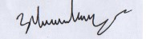

Jonathan Ward-Langman June 12th 2024

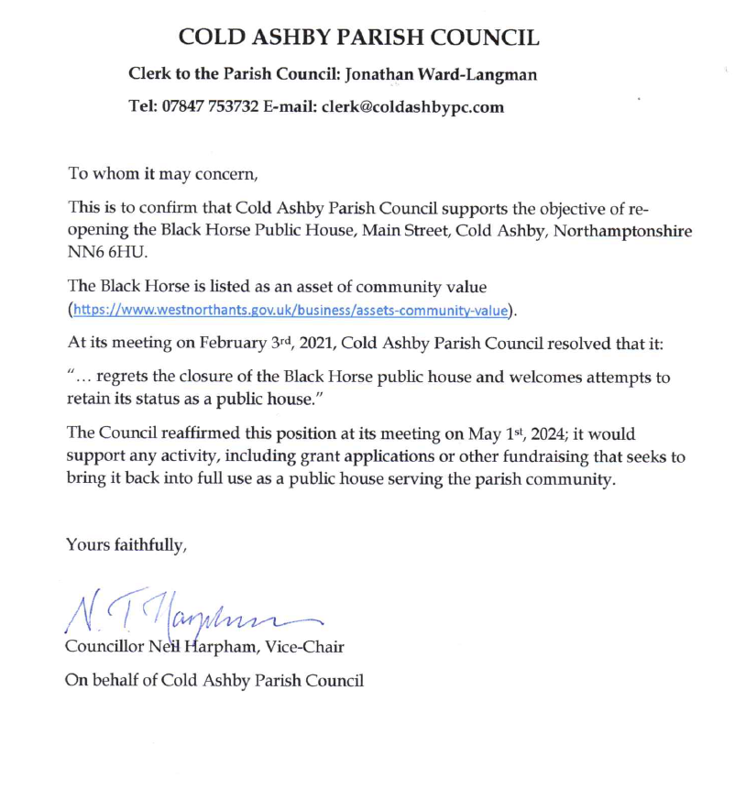

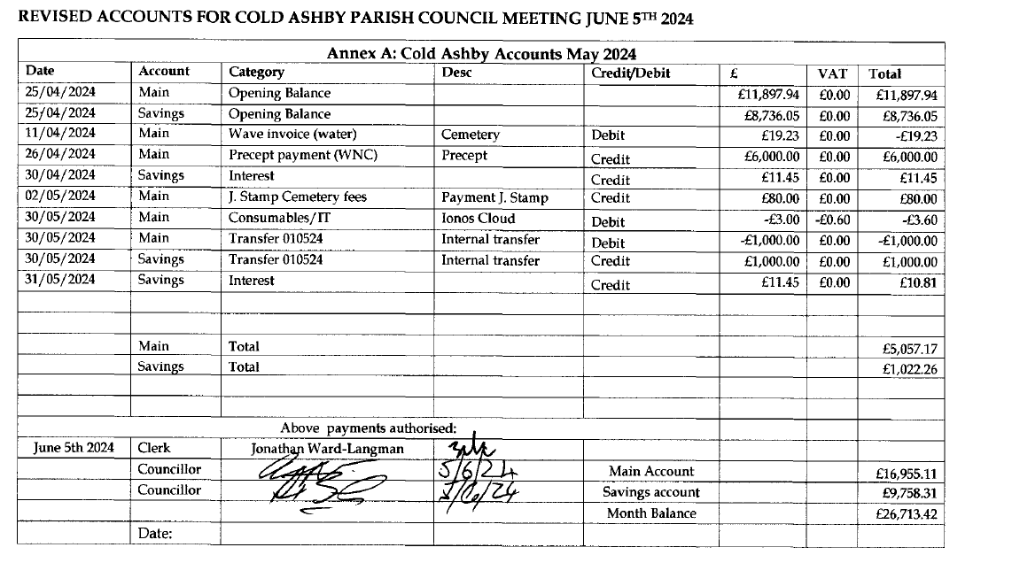
BANK RECONCILIATION FOR COLD ASHBY PARISH COUNCIL MEETING JUNE 6TH 2024
Name of smaller authority: | Cold Ashby Parish Council
County area (local councils and parish meetings only): |  |  | West Northamptonshire
Financial year ending 31 March 2025
Prepared by (Name and Role): | Jonathan Ward-Langman Clerk/ RFO
Date: | 05/06/2024
 |  |  |  |  | £ | £
Balance per bank statements as at 05/06/24
Business Current Account 1045 | account 1 |  |  |  | £16,962.31
Business Reserve Account 2605 | account 2 |  |  |  | £9,758.31
 | account 3
 |  |  |  |  |  | £26,720.62
Petty cash float (if applicable) |  |  |  |  |  | £0.00
Less: any unpresented cheques as at 31/3/24 (enter these as negative numbers)
Owed to Natalie Heath. | IONOS Cloud payment 29/03/24 |  |  |  | £3.60 | £0.00
Owed to Natalie Heath. | IONOS Cloud payment 30/05/24 |  |  |  | £3.60
 |  |  |  |  |  | £7.20
Add: any un-banked cash as at 31/3/24 |  |  |  |  | £0.00
 |  |  |  |  |  | £0.00
Net balances as at 05/06/24 (Box 8) |  |  |  |  |  | £26,713.42

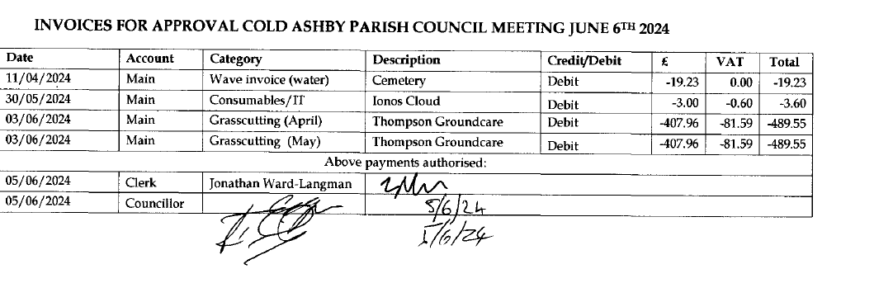
Annex B
Cold Ashby Parish Council
Recording at Parish Council Meetings Policy
March 2024
CONTENTS
Detail of chapters | Page Number
Introduction | 1
Parish Council recording obligations and duties | 2
Rules of members of public or press recording the Parish Council meetings | 3

1. INTRODUCTION
- This policy will cover the recording of Parish Meetings by members of the community as well as the Council itself recording the meeting.
- The term “recording” covers the audio, visual or any kind of electronic recording.
- The right to record, film and to broadcast meetings of the parish meeting is established under the Openness of Local Government Regulations 2014. This is in addition to the rights of the press and public to attend such meetings.
- The Council is committed to being open and transparent in the way it conducts its decision making.
- The Council fully appreciates that any recording of meetings will need to be stored securely and will be covered by Freedom of Information (FoI) and General Data Protection Regulations (GDPR) legislation.
- All Council meetings may be recorded in either a visual, audible or electronic manner. Recording of a meeting or a section of a meeting will be clearly noted in the minutes
- The physical minutes of the meeting, which are usually taken by the Clerk and voted by the Full Council at the next Full Council meeting will remain the statutory and legally binding formal record of council decisions.
- In any discrepancy between any recordings and written minutes, the Council are steadfast in using the written minutes as the primary record.

2. COUNCIL RECORDING OBLIGATIONS AND DUTIES
- The Parish Council may itself photograph, film, record or broadcast meetings and can retain, use or dispose of such material in accordance with its retention and disposal policies.
- Where a council records its own meetings, it will be bound by this policy.
- The Council will ensure that in all face-to-face meetings, there are clear signs of the fact that the meeting is being recorded.
- The Chair will propose a motion when recording is not appropriate for either a full meeting or a section of meeting – if agreed this will be clearly noted in the minutes.
- If any Council meeting is held digitally, the Chair will ensure that it is clearly expressed that the meeting is being recorded.
- The Councillors, Clerks and Council officers have given their permission to be recorded as part of their role.
- Any members of the public or press who have attended any meeting (both face to face and digitally) will be warned by the Chair that by remaining at the meeting they have in effect given their express permission to be recorded. If any members of the public or press do not want to be filmed, they may choose to leave the meeting before recording commences or to move to an area outside the range of the Council’s recording equipment.
- The Clerk shall ensure that for any meetings that are recorded, the act of the recording is made clear in the minutes.
- Council shall ensure that any recording is held securely behind a password protected access process. Any request for access by any persons (other than the Clerk) should be made in writing to the Chair who will take the request to the next full meeting for discussion and a decision to grant the request – this will be highlighted in the publication scheme.
- The Council will determine that how long the recordings are kept and it will be detailed in the Retention and Disposal of Documents and Data Policy. The policy will have specific reference to the GDPR and best practice guidance from the Information Commissioners Office (ICO).
3. RULES OF MEMBERS OF THE PUBLIC RECORDING MEETINGS
- The Council recognises that the general public have a right to record the meetings.
- The Chair will remind all members of the public in attendance of the meeting or a participant in the digital meeting that the act of recording is with permission of the Council.
- In regard to agenda points when the public and press are excluded, no recording by the press or public will be permitted.
- The Chair will remind all members of the public and press that any recording of any meetings (either in full or part) will not be permitted to cause any disruption of any part of the Council meeting.
- Any person making the recording may move around, however in doing so they must ensure that there is minimal or no disruption to the proceedings of the meeting.
- The council requests that all recording is overt (i.e. clearly visible to anyone at the meeting).
- A person or persons making a recording has no right to interrupt the formal part of the Parish meeting by asking questions or making comments for the purpose of the recording.
- The person recording has no right to ask councillors, officers or any members of the public who have been given permission to contribute orally to the meeting to repeat a statement for the purposes of the recording.
- The Chairman of the meeting has absolute discretion to stop or suspend recording if, in their reasonable opinion, continuing to do so would prejudice proceedings at the meeting or if the person recording is in breach of these rules.
- Persons who are recording are requested not to leave their equipment unattended where possible and are responsible for their equipment at all times.
- The recording and reporting on meetings of the Parish Council, is subject to the law and it is the responsibility of those doing the recording and reporting to ensure compliance.
- The council expects that the recording will not be edited in a way that could lead to misinterpretation or misrepresentation of the proceedings or infringement of the Parish Council’s values or in a way that ridicules or shows a lack of respect for those in the recording.
- The Parish Council would expect any recording in breach of these rules to be removed from public view. The Parish Council will have no liability for material published by any other person unless it is itself undertaking the publication through its offices.
- The Parish Council is not liable for the actions of any person making a recording at a council meeting which identifies a member of the public or for any publication of that recording.
- The Council cannot be held responsible for recordings of its meetings made by members of the public or for their distribution or amendment and editing.

Annex C
Records Retention Policy

Cold Ashby Parish Council recognises that the efficient management of its records is necessary to comply with its legal and regulatory obligations and to contribute to the effective overall management of the association. This document provides the policy framework through which this effective management can be achieved and audited.
It covers:
• Scope
• Responsibilities
• Retention Schedule

Scope

This policy applies to all records created, received or maintained by Cold Ashby Parish Council in the course of carrying out its functions. Records are defined as all those documents which facilitate the business carried out by Cold Ashby Parish Council and which are thereafter retained (for a set period) to provide evidence of its transactions or activities. These records may be created, received or maintained in hard copy or electronically. A small percentage of Cold Ashby Parish Council records may be selected for permanent preservation as part of the Councils archives and for historical research.

Responsibilities
Cold Ashby Parish Council has a corporate responsibility to maintain its records and record management systems in accordance with the regulatory environment. The person with overall responsibility for this policy is the Clerk. The person responsible for records management will give guidance for good records management practice and will promote compliance with this policy so that information will be retrieved easily, appropriately and timely. Individual staff and employees must ensure that records for which they are responsible are accurate, and are maintained and disposed of in accordance with Cold Ashby Parish Council records management guidelines.

Retention Schedule
The retention schedule refers to record series regardless of the media in which they are stored.
Document | Minimum Retention Period | Reason
Minutes
Minutes of Council meetings | Indefinite | Archive
Minutes of committee meetings | Indefinite | Archive
Employment
Staff employment contracts | 6 years after ceasing employment | Management
Staff payroll information | 3 years | Management
Staff references | 6 years after ceasing employment | Management
Application forms (interviewed – unsuccessful) | 6 months | Management
Application forms (interviewed – successful) | 6 years after ceasing employment | Management
Disciplinary files | 6 years after ceasing employment | Management
Staff appraisals | 6 years after ceasing employment | Management
Finance
Scales of fees and charges | 6 years | Management
Receipt and payment accounts | 6 years | VAT
Bank statements | Last completed audit year | Audit
Cheque book stubs | Last completed audit year | Audit
Paid invoices | Last completed audit year | VAT
Paid cheques | Last completed audit year | Limitation Act 1980
Payroll records | 3 years | HMRC
Petty cash accounts | Last completed audit year | Audit
Insurance
Insurance policies | 6 years after policy end | Management
Certificates for Insurance against liability for employees | 6 years after policy end | Management
Certificates for Public Liability | 6 years after policy end | Management
Insurance claim records | 6 years after policy end | Management
Health and Safety
Accident books | 3 years from date of last entry | Statutory
Risk assessment | 3 years | Management
General Management
Councillors contact details | Duration of membership | Management
Lease agreements | 12 years | Limitation Act 1980
Contracts | 6 years (12 years for deeds) | Limitation Act 1980
Email messages | At end of useful life | Management
Consent forms | 5 years | Management
GDPR Security Compliance form | Duration of membership | Management
Recordings of Parish Council Meetings | 3 months | Management

Annex D
Annual Governance and Accountability Return 2023/24 Form 2

To be completed only by Local Councils, Internal Drainage Boards and other smaller authorities* where the higher of gross income or gross expenditure was £25,000 or less, that meet the qualifying criteria, and that wish to CERTIFY themselves as EXEMPT from a limited assurance review
Guidance notes on completing Form 2 of the Annual Governance and Accountability Return 2023/24
- Every smaller authority in England where the higher of gross income or gross expenditure was £25,000 or less must, after the end of each financial year, complete Form 2 of the Annual Governance and Accountability Return in accordance with Proper Practices, unless the authority:
  - does not meet the qualifying criteria for exemption; or
  - does not wish to certify itself as exempt
- Smaller authorities where the higher of all gross annual income or gross annual expenditure does not exceed £25,000 and that meet the qualifying criteria as set out in the Certificate of Exemption are able to declare themselves exempt from sending the completed Annual Governance and Accountability Return to the external auditor for a limited assurance review provided the authority completes:
  - The Certificate of Exemption, page 3 and returns a copy of it to the external auditor either by email or by post (not both) no later than 30 June 2024. Failure to do so will result in reminder letter(s) for which the
Authority will be charged £40 +VAT for each letter; and
  - The Annual Governance and Accountability Return (Form 2) which is made up of:
  - Annual Internal Audit Report (page 4) must be completed by the authority’s internal auditor.
  - Section 1 – Annual Governance Statement (page 5) must be completed and approved by the authority.
  - Section 2 – Accounting Statements (page 6) must be completed and approved by the authority. NOTE: Authorities certifying themselves as exempt SHOULD NOT send the completed Annual Governance and Accountability Return to the external auditor.
- The authority must approve Section 1 Annual Governance Statement before approving Section 2 Accounting Statements and both must be approved and published on the authority website/webpage before 1 July 2024.

Publication Requirements
Smaller authorities must publish various documents on a publicly available website as required by the Accounts and Audit Regulations 2015, the Local Audit (Smaller Authorities) Regulations 2015 and the Transparency Code for Smaller Authorities. These include:
- Certificate of Exemption, page 3
- Annual Internal Audit Report 2023/24, page 4
- Section 1 – Annual Governance Statement 2023/24, page 5
- Section 2 – Accounting Statements 2023/24, page 6
- Analysis of variances • Bank reconciliation
- Notice of the period for the exercise of public rights and other information required by Regulation 15 (2), Accounts and Audit Regulations 2015.

Limited Assurance Review
Any smaller authority may request a limited assurance review. If so, the authority should not certify itself as exempt or complete the Certificate of Exemption. Instead it should complete Form 3 of the AGAR 2023/24 and return it to the external auditor together with the supporting documentation requested by the external auditor. The cost to the authority for the review will be £210 +VAT.
Provided that the authority certifies itself as exempt, and completes and publishes the documents listed under ‘Publication Requirements’, there is no requirement for the authority to have a review.
The Annual Governance and Accountability Return constitutes the annual return referred to in the Accounts and Audit Regulations 2015. Throughout, the words ‘external auditor’ have the same meaning as the words ‘local auditor’ in the Accounts and Audit Regulations 2015.
*for a complete list of bodies that may be smaller authorities refer to schedule 2 to the Local Audit and Accountability Act 2014.
3/24 Form 2

Guidance notes on completing Form 2 of the Annual Governance and Accountability Return (AGAR) 2023/24, Sections 1 and 2
- An authority that wishes to declare itself exempt from the requirement for a limited assurance review must do so at a meeting of the authority after 31 March 2024. It should not submit its Annual Governance and Accountability Return to the external auditor. However, as part of a more proportionate regime, the authority must comply with the requirements of the Transparency Code for Smaller Authorities.
- The Certificate of Exemption must be returned to the external auditor no later than 30 June 2024. Reminder letters will incur a charge of £40 +VAT for each letter.
- The authority must comply with Proper Practices in completing Sections 1 and 2 of this AGAR and the Certificate of Exemption. Proper Practices are found in the Practitioners’ Guide* which is updated from time to time and contains everything needed to prepare successfully for the financial year-end.
- The authority should receive and note the Annual Internal Audit Report before approving the Annual Governance Statement and the accounts.
- The Annual Governance Statement (Section 1) must be approved on the same day or before the Accounting Statements (Section 2) and evidenced by the agenda or minute references
- The Responsible Financial Officer (RFO) must certify the accounts (Section 2) before they are presented to the authority for approval. The authority must in this order; consider, approve and sign the accounts.
- The RFO is required to commence the public rights period as soon as practical after the date of the AGAR approval.
- Make sure that the AGAR is complete (no highlighted boxes left empty), and is properly signed and dated. Any amendments must be approved by the authority and properly initialled.
- Use the checklist provided below to review the AGAR for completeness at the meeting at which it is signed off.
- You must inform your external auditor about any change of Clerk, Responsible Financial Officer or Chair, and provide relevant authority owned generic email addresses and telephone numbers.
- The authority must publish numerical and narrative explanations for significant variances in the accounting statements on page 6. Guidance is provided in the Practitioners’ Guide* which may assist.
- Make sure that the accounting statements add up and the balance carried forward from the previous year(Box 7 of 2023) equals the balance brought forward in the current year (Box 1 of 2024).
- The Responsible Financial Officer (RFO), on behalf of the authority, must set the commencement date for the exercise of public rights of 30 consecutive working days which must include the first ten working days of July.
- The authority must publish, on the authority website/webpage, the information required by Regulation 15 (2), Accounts and Audit Regulations 2015, including the period for the exercise of public rights and the name and address of the external auditor before 1 July 2024.
Completion checklist – ‘No’ answers mean you may not have met requirements |  | Yes | No
All sections | Have all highlighted boxes been completed?
All sections | Have the dates set for the period for the exercise of public rights been published?
Internal Audit Report | Have all highlighted boxes been completed by the internal auditor and explanations provided?
Section 1 | For any statement to which the response is ‘no’, is an explanation available for publication?
Section 2 | Has the Responsible Financial Officer signed the accounting statements before presentation to the authority for approval?
Section 2 | Has the authority’s approval of the accounting statements been confirmed by the signature of the Chair of the approval meeting?
Section 2 | Has an explanation of significant variations been published where required?
Section 2 | Has the bank reconciliation as at 31 March 2024 been reconciled to Box 8?
Section 2 | Is an explanation of any difference between Box 7 and Box 8 available, should a question be raised by a local elector and/or an interested party?
Sections 1 and 2 | Trust funds – have all disclosures been made if the authority as a body corporate is a sole managing trustee? (Local Councils only)
*Governance and Accountability for Smaller Authorities in England – a Practitioners’ Guide to Proper Practices, can be downloaded from www.nalc.gov.uk or from www.ada.org.uk

Certificate of Exemption – AGAR 2023/24 Form 2
To be completed by smaller authorities where the higher of gross income or gross expenditure did not exceed £25,000 in the year of account ended 31 March 2024, and that wish to certify themselves as exempt from a limited assurance review under Section 9 of the Local Audit (Smaller Authorities) Regulations 2015
There is no requirement to have a limited assurance review or to submit an Annual Governance and Accountability Return to the external auditor, provided that the authority has certified itself as exempt at a meeting of the authority after 31 March 2024 and a completed Certificate of Exemption is submitted no later than 30 June 2024 notifying the external auditor.

COLD ASHBY PARISH COUNCIL
certifies that during the financial year 2023/24, the higher of the authority’s total gross income for the year or total gross annual expenditure, for the year did not exceed £25,000
£17,800.40

£13,062.72

Total annual gross income for the authority 2023/24:
Total annual gross expenditure for the authority 2023/24:
There are certain circumstances in which an authority will be unable to certify itself as exempt, so that a limited assurance review will still be required. If an authority is unable to confirm the statements below then it cannot certify itself as exempt and it must submit the completed Annual Governance and Accountability Return Form 3 to the external auditor to undertake a limited assurance review for which a fee of £210 +VAT will be payable.
By signing this Certificate of Exemption you are confirming that:
- The authority was in existence on 1st April 2020
- In relation to the preceding financial year (2022/23), the external auditor has not:
- issued a public interest report in respect of the authority or any entity connected with it
- made a statutory recommendation to the authority, relating to the authority or any entity connected with it
- issued an advisory notice under paragraph 1(1) of Schedule 8 to the Local Audit and Accountability Act 2014 (“the Act”), and has not withdrawn the notice
- commenced judicial review proceedings under section 31(1) of the Act
- made an application under section 28(1) of the Act for a declaration that an item of account is unlawful, and the application has not been withdrawn nor has the court refused to make the declaration
- The court has not declared an item of account unlawful after a person made an appeal under section 28(3) of the Act.
If the above statements apply and the authority neither received gross income, nor incurred gross expenditure, exceeding £25,000, then the Certificate of Exemption can be signed and a copy submitted to the external auditor either by email or by post (not both).
The Annual Internal Audit Report, Annual Governance Statement, Accounting Statements, an analysis of variances and the bank reconciliation plus the information required by Regulation 15 (2), Accounts and Audit Regulations 2015 including the period for the exercise of public rights still need to be fully completed and, along with a copy of this certificate, published on the authority website/webpage* before 1 July 2024. Signing this certificate confirms the authority will comply with the publication requirements.

DD/MM/YYYY
SIGNATURE REQUIRED |  | DD/MM/YYYY
MINUTE REFERENCE
SIGNATURE REQUIRED |  | DD/MM/YYYY
Signed by the Responsible Financial Officer DateI confirm that this Certificate of Exemption was approved by this authority on this date:
Signed by Chair Date as recorded in minute reference:
Generic email address of Authority Telephone number
clerk@coldashbypc.com |  | 07847 753732
*Published web address

www.parish-council.com/coldashby/
ONLY this Certificate of Exemption should be returned EITHER by email OR by post (not both) as soon as possible after certification to your external auditor, but no later than 30 June 2024. Reminder letters for late submission will incur a charge of £40 + VAT.

Annual Internal Audit Report 2023/24
ENTER NAME OF AUTHORITY

ENTER PUBLICLY AVAILABLE WEBSITE/WEBPAGE ADDRESS
During the financial year ended 31 March 2024, this authority’s internal auditor acting independently and on the basis of an assessment of risk, carried out a selective assessment of compliance with the relevant procedures and controls in operation and obtained appropriate evidence from the authority.
The internal audit for 2023/24 has been carried out in accordance with this authority’s needs and planned coverage. On the basis of the findings in the areas examined, the internal audit conclusions are summarised in this table. Set out below are the objectives of internal control and alongside are the internal audit conclusions on whether, in all significant respects, the control objectives were being achieved throughout the financial year to a standard adequate to meet the needs of this authority.
Internal control objective |  | Yes |  | No* |  | Not covered**
A. Appropriate accounting records have been properly kept throughout the financial year.
B. This authority complied with its financial regulations, payments were supported by invoices, all expenditure was approved and VAT was appropriately accounted for.
C. This authority assessed the significant risks to achieving its objectives and reviewed the adequacy of arrangements to manage these.
D. The precept or rates requirement resulted from an adequate budgetary process; progress against the budget was regularly monitored; and reserves were appropriate.
E. Expected income was fully received, based on correct prices, properly recorded and promptly banked; and VAT was appropriately accounted for.
F. Petty cash payments were properly supported by receipts, all petty cash expenditure was approved and VAT appropriately accounted for.
G. Salaries to employees and allowances to members were paid in accordance with this authority’s approvals, and PAYE and NI requirements were properly applied.
H. Asset and investments registers were complete and accurate and properly maintained.
I. Periodic bank account reconciliations were properly carried out during the year.
J. Accounting statements prepared during the year were prepared on the correct accounting basis (receipts and payments or income and expenditure), agreed to the cash book, supported by an adequate audit trail from underlying records and where appropriate debtors and creditors were properly recorded.
K. If the authority certified itself as exempt from a limited assurance review in 2022/23, it met the exemption criteria and correctly declared itself exempt. (If the authority had a limited assurance review of its 2022/23 AGAR tick “not covered”)
L. The authority published the required information on a website/webpage up to date at the time of the internal audit in accordance with the relevant legislation.
M. In the year covered by this AGAR, the authority correctly provided for a period for the exercise of public rights as required by the Accounts and Audit Regulations (during the 2023-24 AGAR period, were public rights in relation to the 2022-23 AGAR evidenced by a notice on the website and/or authority approved minutes confirming the dates set).
N. The authority has complied with the publication requirements for 2022/23 AGAR (see AGAR Page 1 Guidance Notes).
 | O. (For local councils only)  Trust funds (including charitable) – The council met its responsibilities as a trustee. |  | Yes |  | No |  | Not applicable
For any other risk areas identified by this authority adequate controls existed (list any other risk areas on separate sheets if needed).
Date(s) internal audit undertaken Name of person who carried out the internal audit
DD/MM/YYYY DD/MM/YYYY DD/MM/YYYY |  | ENTER NAME OF INTERNAL AUDITOR
Signature of person who
SIGNATURE REQUIRED |  | DD/MM/YYYY
carried out the internal audit Date
*If the response is ‘no’ please state the implications and action being taken to address any weakness in control identified (add separate sheets if needed).
**Note: If the response is ‘not covered’ please state when the most recent internal audit work was done in this area and when it is next planned; or, if coverage is not required, the annual internal audit report must explain why not (add separate sheets if needed).

Section 1 – Annual Governance Statement 2023/24
We acknowledge as the members of:

COLD ASHBY PARISH COUNCIL
our responsibility for ensuring that there is a sound system of internal control, including arrangements for the preparation of the Accounting Statements. We confirm, to the best of our knowledge and belief, with respect to the Accounting Statements for the year ended 31 March 2024, that:
Agreed
 | Yes | No | ‘Yes’ means that this authority:
1. We have put in place arrangements for effective financial management during the year, and for the preparation of the accounting statements. | √ |  | prepared its accounting statements in accordance with the Accounts and Audit Regulations.
2. We maintained an adequate system of internal control including measures designed to prevent and detect fraud and corruption and reviewed its effectiveness. | √ |  | made proper arrangements and accepted responsibility for safeguarding the public money and resources in its charge.
3. We took all reasonable steps to assure ourselves that there are no matters of actual or potential non-compliance with laws, regulations and Proper Practices that could have a significant financial effect on the ability of this authority to conduct its business or manage its finances. | √ |  | has only done what it has the legal power to do and has complied with Proper Practices in doing so.
4. We provided proper opportunity during the year for the exercise of electors’ rights in accordance with the requirements of the Accounts and Audit Regulations. | √ |  | during the year gave all persons interested the opportunity to inspect and ask questions about this authority’s accounts.
5. We carried out an assessment of the risks facing this authority and took appropriate steps to manage those risks, including the introduction of internal controls and/or external insurance cover where required. | √ |  | considered and documented the financial and other risks it faces and dealt with them properly.
6. We maintained throughout the year an adequate and effective system of internal audit of the accounting records and control systems. | √ |  | arranged for a competent person, independent of the financial controls and procedures, to give an objective view on whether internal controls meet the needs of this smaller authority.
7. We took appropriate action on all matters raised in reports from internal and external audit. | √ |  | responded to matters brought to its attention by internal and external audit.
8. We considered whether any litigation, liabilities or commitments, events or transactions, occurring either during or after the year-end, have a financial impact on this authority and, where appropriate, have included them in the accounting statements. | √ |  | disclosed everything it should have about its business activity during the year including events taking place after the year end if relevant.
9. (For local councils only) Trust funds including charitable. In our capacity as the sole managing trustee we discharged our accountability responsibilities for the fund(s)/assets, including financial reporting and, if required, independent examination or audit. | Yes | No | N/A | has met all of its responsibilities where as a body corporate it is a sole managing trustee of a local trust or trusts.
 |  |  | √
*For any statement to which the response is ‘no’, an explanation must be published
SIGNATURE REQUIRED
MINUTE REFERENCE
SIGNATURE REQUIRED
This Annual Governance Statement was approved at a Signed by the Chair and Clerk of the meeting where meeting of the authority on:approval was given:

DD/MM/YYYY
and recorded as minute reference:^{Chair}
Clerk
Information required by the Transparency Code (not part of the Annual Governance Statement)
The authority website/webpage is up to date and the information required by the Transparency Code has been published. | Yes | No
ENTER PUBLICLY AVAILABLE WEBSITE/WEBPAGE ADDRESS
3/24 Form 2

Section 2 – Accounting Statements 2023/24 for
COLD ASHBY PARISH COUNCIL
 | Year ending |  |  |  | Notes and guidance
 | 31 March  2023  £ |  | 31 March  2024  £ |  | Please round all figures to nearest £1. Do not leave any boxes blank and report £0 or Nil balances. All figures must agree to underlying financial records.
1. Balances brought forward | 17748 |  | 17089 |  | Total balances and reserves at the beginning of the year as recorded in the financial records. Value must agree to Box 7 of previous year.
2. (+) Precept or Rates and Levies | 10000 |  | 12000 |  | Total amount of precept (or for IDBs rates and levies) received or receivable in the year. Exclude any grants received.
3. (+) Total other receipts | 3135 |  | 5800 |  | Total income or receipts as recorded in the cashbook less the precept or rates/levies received (line 2). Include any grants received.
4. (-) Staff costs | 2897 |  | 3260 |  | Total expenditure or payments made to and on behalf of all employees. Include gross salaries and wages, employers NI contributions, employers pension contributions, gratuities and severance payments.
5. (-) Loan interest/capital repayments | 0 |  | 0 |  | Total expenditure or payments of capital and interest made during the year on the authority’s borrowings (if any).
6. (-) All other payments | 10897 |  | 9802 |  | Total expenditure or payments as recorded in the cashbook less staff costs (line 4) and loan interest/capital repayments (line 5).
7. (=) Balances carried forward | 17089 |  | 21827 |  | Total balances and reserves at the end of the year. Must equal (1+2+3) - (4+5+6).
8. Total value of cash and short term investments | 17089 |  | 21827 |  | The sum of all current and deposit bank accounts, cash holdings and short term investments held as at 31 March – To agree with bank reconciliation.
9. Total fixed assets plus long term investments and assets | 29998 |  | 29998 |  | The value of all the property the authority owns – it is made up of all its fixed assets and long term investments as at 31 March.
10. Total borrowings | 0 |  | 0 |  | The outstanding capital balance as at 31 March of all loans from third parties (including PWLB).
For Local Councils Only |  | Yes | No | N/A
11a. Disclosure note re Trust funds (including charitable) |  |  |  |  | The Council, as a body corporate, acts as sole trustee and is responsible for managing Trust funds or assets.
11b. Disclosure note re Trust funds (including charitable) |  |  |  | √ | The figures in the accounting statements above exclude any Trust transactions.

I certify that for the year ended 31 March 2024 the Accounting
Statements in this Annual Governance and Accountability Return have been prepared on either a receipts and payments or income and expenditure basis following the guidance in Governance and Accountability for Smaller Authorities – a Practitioners’ Guide to Proper Practices and present fairly the financial position of this authority.
Signed by Responsible Financial Officer before being presented to the authority for approval

SIGNATURE REQUIRED
Date
I confirm that these Accounting Statements were approved by this authority on this date:
DD/MM/YYYY
as recorded in minute reference:

MINUTE REFERENCE
Signed by Chair of the meeting where the Accounting Statements were approved
DD/MM/YYYY
SIGNATURE REQUIRED

